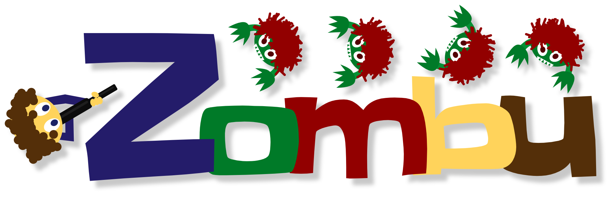
Quick Guide to the Zombu...
Clark Winkelmann


Table of content

Table of content 1
Introduction 1
Theory 2
Character 2
Difficulty 2
Levels 2
Rounds 3
Enhancements 3
Unlock enhancements 3
How to play ? 4
Main menu 4
Controls 4
Game window 5
Status 6
Elements of the game 6
End of the round 7
Go to next round 8
Shop 8
Game over 8
About 9

Introduction
You're left alone facing a horde of enraged Zombies, ready to pounce on you without scruple. Unfortunately for them, you have in your possession a weapon, rustic course, but you can defend yourself.

Oh yes, you can try to unlock ameliorations in the shop with the letters (A, B, C...) occasionally dropped by the Zombies. It will ask for a bit of thought, and you only have a limited number of trials.

Other than that, no problems in sight.

Theory

Character
Unfortunately for you, you have to play as a cauliflower-headed man =(.

Difficulty
So that you do not suffer too fast, you can choose a level of difficulty for your game, namely :
Hardcore
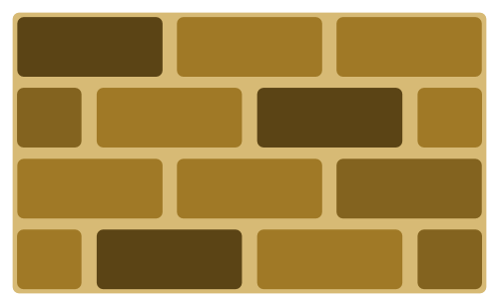
The easiest level, there are not many Zombies, you have a generous amount of life and ammunition and you are sure to get a letter for each killed zombie.
Insane
It gets complicated! Less ammunition and your life is rather limited. Be sure to check out their level during the game. There are more zombies, but they only have a half chance of giving a letter. The dimensions of the playing area are reduced.
Impossible
Courage, hero! You will quickly get out of ammunition on a tiny playground facing countless Zombies! The chances of getting a letter are further reduced!

So you can start slowly and add spice thereafter.

Levels
The level is the first difficulty factor after the difficulty itself. The higher the level, the higher the number of Zombies and the appearance frequency.
During a level, you can improve at most once every property (see Enhancements).
To move to the next level, you must reach a certain number of points. When this number is reached, you may suffer in the next level or continue playing at the current level to unlock the remaining enhancements.

Rounds
At the beginning of a round, all your properties are at maximum (Life, Ammunition, ...).
To win the round, you have to kill all the Zombies that appear. Their number and their apparition frequency depend on the level, the round number, and the chosen difficulty.
Success
If you manage to defeat the Zombies, you have the opportunity to move to the next round, or switching to a higher level if you have enough points.
You can use the letters picked to try to unblock an advantage in the shop.
Fail
When you have lost the wave, you can restart it or move to a higher level if you had enough points after the last round you won.
You can also return to the main menu to start over (with another difficulty ?) Or just leave that damn game (I'd be sorry).
Letters picked during the round and the points obtained (If you have any) are lost. In fact when you restart a round it's as if you had never played the failed one.

Enhancements
The shop allows you to improve your following characteristics:
Life To suffer a little longer !
The amount of life you have. When a Zombie touches you, you lose a number of health points. This improvement gives you more health points.
Ammunition Because we love shooting into emptiness !
Your stock of ammunition. The more you have... the more you can draw!
Shooting speed To get faster out of ammunition !
Reduces the interval between two shots. You can shoot bursts of shots more demonic than ever, but beware of the stock of ammunition!
Moving speed Zombu gives you leeegs ♫ !
You can move faster.

Unlock enhancements
To unlock an advantage, you need to solve the corresponding "Hangman". You can try it at the end of each round using the letters (some or all) picked during the game. The remaining letters you don't use will be lost (You will need to pick them again if you need them). At the 10th error the mystery word is lost. If you found the word, the improvement is applied immediately.
You can continue to try to unblock the same advantage throughout the level. When you go to the next level unlocked benefits are replaced by better ones and those not found are reset.

How to play ?
This part of the guide will introduce you to the different elements of the graphical interface and how to interact with them.

Main menu

When you start the game, you are facing the Main Menu.
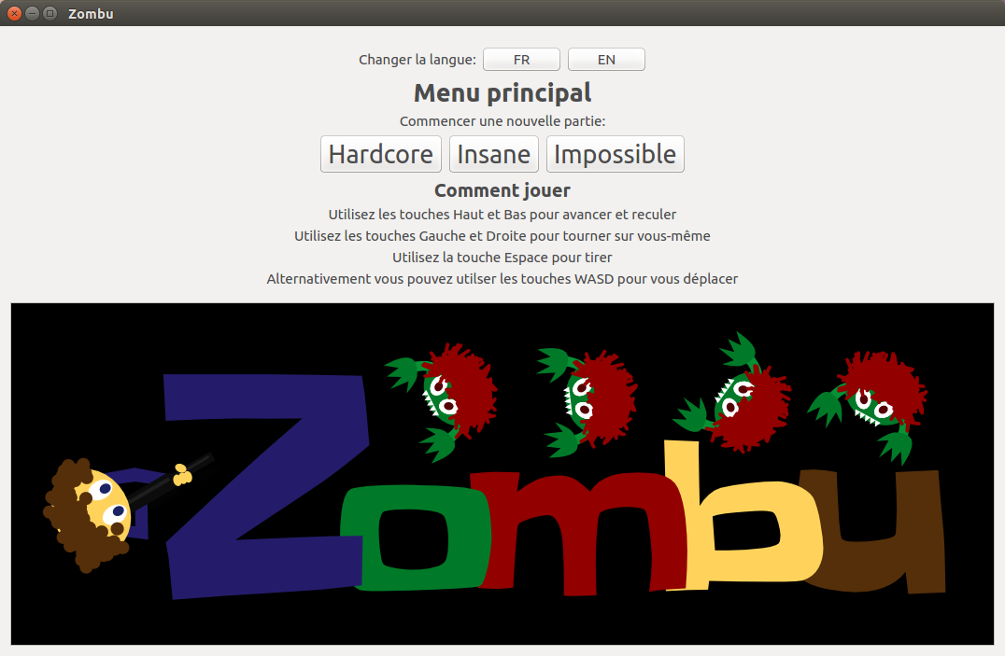
It allows you to start a new game in the difficulty of your choice.
By default the game starts in the language for your system. You can change it with the buttons at the top of the window.

Controls
Use the UP and DOWN keys to move forward or backward.
Use the LEFT and RIGHT keys to turn on yourself.
Use SPACE to shoot.
The R key allows you to restart the round at any time.
The ESC key pause the game.
The V key takes you to the next round (when you are in the shop).
The L key takes you to the next level (when you are in the shop or you lost a round).

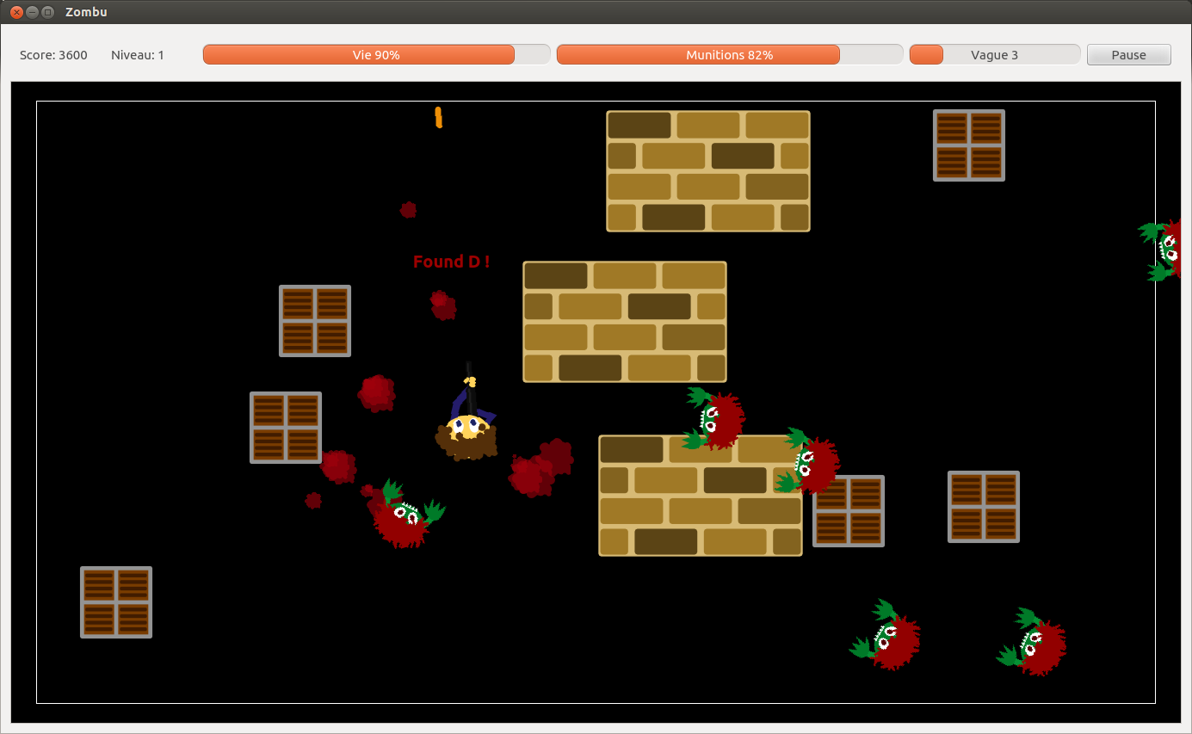
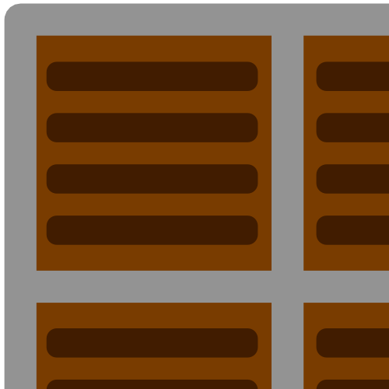
Game window
Zombie
Your score in the level
Current level
% life remaining
% ammunition remaining
Current round and progress
Pause button
Box
Wall
Whatever the level, the round or difficulty, the game window is always the same.
Hero
Missile
Limits of play area
Text announcing
a new letter
Blood

Status
At the top of the screen you have access to informations on the state of the game.
Score : The current score in the level
Level : Current Level
Life : Percentage of remaining life
Ammunition : Percentage of remaining stock of ammunition
Round : Indicates the round number and the progress of it. Progress is the number of Zombies killed on the total number of Zombies (Including those that have not yet appeared)
Pause : Pause the game (Same as ESC)

Elements of the game
Hero (You)

The cauliflower-headed man and his diabolical weapon! Who dares to touch him... Touches him.

Missile
It's ... a missile. What your weapon shoot. It can rebound against obstacles (max 5 times).
Zombie (Who will eat you)

The Zombie always moves towards its target (At least he tries, because he forgot his glasses).
He just needs to touch you with the tip of his finger for you to be a victim of zombulistrophia.
Box

The box is an obstacle that only blocks the missiles. Do not expect to hit the Zombie approaching from behind!

Wall
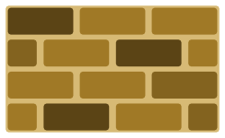
The wall is blocking both creatures and missiles. Zombies sometimes collide into it without reason...

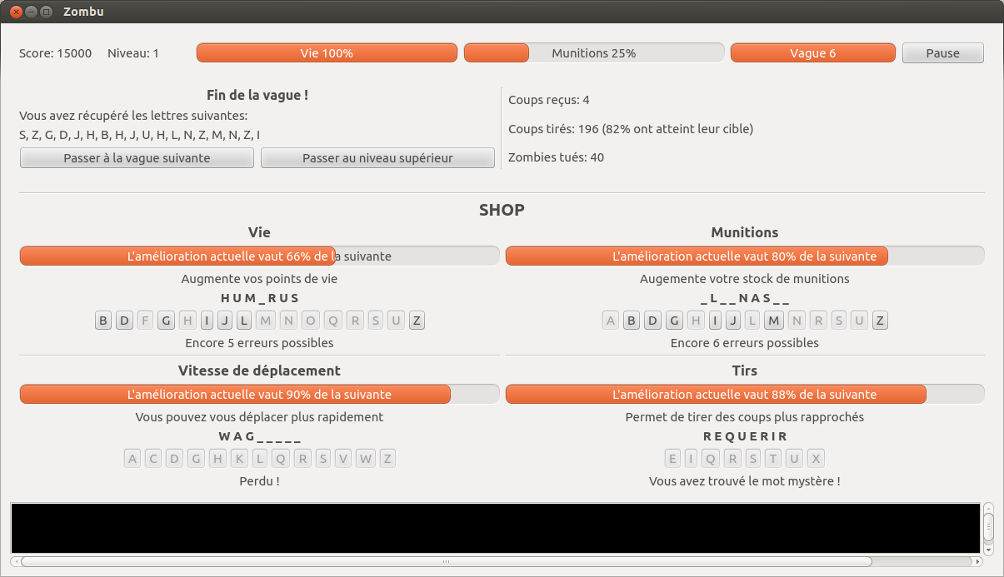

End of the round
Statistics
Letters picked
Options to continue
Word not found
Word totally discovered
Word as it is discoverd
Playable letters for that word
Number of errors still allowed

Go to next round
The “Next round” button or V key takes you to the next round.
The “Level up” button or L key takes you to the upper level. If you don't have enough points, the button will be grayed out and display the required amount of points, e.g.: “Level up – Score of 4000 required”

Shop
The shop displays the mystery words for each enhancement.
Value of the improvement
The progress bar displays the value that you currently have compared to the one you would have by unlocking.
Word discovered
The word is displayed as you found out now. The letters not found are replaced by _.
List of letters
Displays the letters already played (grayed out) and letter that you can try. If you guessed the word but not picked the necessary letters, you will have to wait until you get them !
Allowed errors
The number of errors still allowed is displayed below the list of letters.

Game over
No it is not over! You have the option to retry the round you just lose clicking “Restart round” or pressing R.
If you had enough points to move to the next level at the end of the last round, you can switch to the new level with L.
You can also leave the game to the main menu to start a new one by clicking “Main menu”.
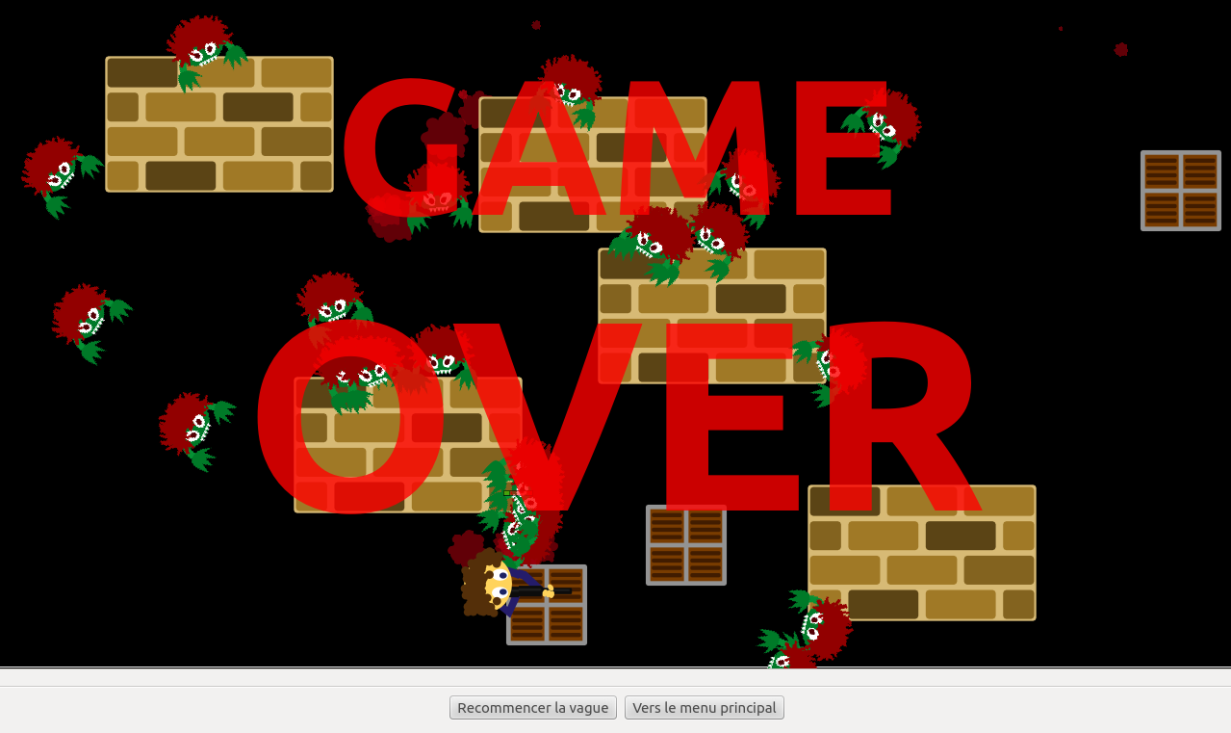


About
Zombu is a game created by Clark Winkelmann during the “Program a game with Qt Framework” workshop at the École des Métiers Techniques de Porrentruy, and now maintained as an independent project.

More informations, downloads and source code on zombu.rip

